Student Profile
E
CA
AC
EA
AA
AM
AP
Name:
Emergent |  |  | to | One to One Counting | Date achieved
I am learning to ... |  |  |  |  | I can ...
Knowledge
Read | The numerals 1 to 10  1 2 3 4 5 6 7 8 9 10
Say | The numbers 1 to 10 forwards:  1 2 3 4 5 6 7 8 9 10
Say | The numbers 10 to 1 backwards:  10 9 8 7 6 5 4 3 2 1
Strategy
Count |  | The number of objects in a set up to 10  1 2 3 4 5 6 7  

Student Profile
E
CA
AC
EA
AA
AM
AP
Name:
One to One Counting |  |  | to | Counting from One on Materials | Date achieved
I am learning to ... |  |  |  |  | I can ...
Knowledge
Read | The numerals 1 to 20  1 2 3 4 5 6 7 8 9 10  11 12 13 14 15 16 17 18 19 20
Say | The next number after from 1 to 10  3 4 7 8
Say | The number before from 1 to 10  4 5 9 10
Know | Patterns for numbers 1 to 5  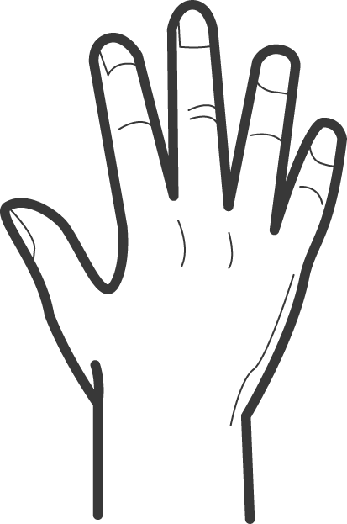
Strategy
Join |  | Groups of objects together and find the total up to 10  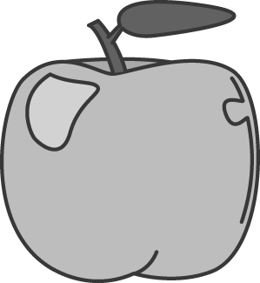 and
Split |  | Groups of objects and find how many are left over  

Student Profile
E
CA
AC
EA
AA
AM
AP
Name:
Counting from One On Materials |  |  | to | Counting from One By Imaging | Date achieved
I am learning to ... |  |  |  |  | I can ...
Knowledge
Skip Count | In 2’s up to 20  2, 4, 6, 8, 10, 12, 14, 16, 18, 20
Say | The next number after from 1 to 20  12 13 18 19
Say | The number before from 1 to 20  11 12 9 10
Know | Patterns for numbers 1 to 10  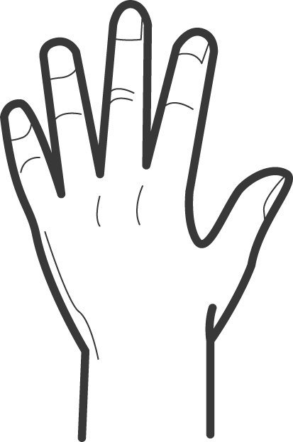
Know | + and – groupings to 5  3 + 2 = 5  5 – 2 = 3
Strategy
Solve |  | Addition problems, up to 10, by counting all the objects in my head.  and
Solve |  | Subtraction problems, up to 10, by counting all the objects in my head.  take away
Student Profile
E
CA
AC
EA
AA
AM
AP
Name:
Counting from One By Imaging |  |  | to | Advanced Counting | Date achieved
I am learning to ... |  |  |  |  | I can ...
Knowledge
Read,Write,  and Count | Whole numbers up to 100, forwards and backwards in 1’s, 2’s, 5’s, and 10’s.
Recall | How many tens in a two-digit number,  e.g. 87 has 8 tens.
Know | Groupings that make up numbers to 10,  e.g. 3 + 7 = 10.
Know | Doubles up to 20 and the matching halves,  e.g. 7 + 7 = 14, ½ of 14 is 7
Know | Groupings with 10,  e.g. 10 + 3 = 13
Strategy
Solve |  | Addition problems, up to 100, by counting on in my head.  38 and  for 38 + 3 = 41
Solve |  | Subtraction problems, up to 100, by counting back in my head.  18, 17, 16, 15  for 19 – 4 = 15
Student Profile
E
CA
AC
EA
AA
AM
AP
Name:
Advanced Counting |  |  | to | Early Additive | Date achieved
I am learning to ... |  |  |  |  | I can ...
Knowledge
Read and Count | Whole numbers up to 1000, in ones, tens and hundreds, e.g. 370, 380, 390, 400, 410...
Recall | How many tens in a three-digit number,  e.g. 456 has 45 tens.
Know | All the addition facts to 20,  e.g. 8 + 7 = 15.
Know | All the 2 ×, 10 ×, 5 × multiplication facts and the matching division facts,  e.g. 35 ÷ 5 = 7.
Strategy
Solve + and – problems by: |  | Using doubles, e.g. 8 + 7 = 15 because  7 + 7 = 14, 16 – 8 = 8 because 8 + 8 = 16.
 |  | Making tens, e.g. 28 + 6 = 30 + 4.
Joining and separating tens and ones,
e.g. 34 + 25 = (30 + 20) + (4 + 5) = 59.
Solve × and ÷ problems by: |  | Using repeated addition,  e.g. 4 × 6 as 6 + 6 = 12, 12 + 12 = 24.
Turning multiplications around,
e.g. 10 × 3 = 3 × 10.
Find a unit fraction of: |  | A set using halving,  e.g. ¼ of 20 as ½ of 20 = 10,  ½ of 10 = 5.
A shape using fold symmetry,
e.g.

Student Profile
E
CA
AC
EA
AA
AM
AP
Name:
Early Additive |  |  | to | Advanced Additive | Date achieved
I am learning to ... |  |  |  |  | I can ...
Knowledge
Read and Order | Whole numbers up to 1 000 000,  e.g. 36 075 < 90 002 < 201 489.
Know | How many 10’s and 100’s are in whole numbers up to 10 000,  e.g. 734 tens are in 7 340.
Read and order | Fractions with the same numerator or denominator,  e.g. $\frac{1}{8}$ < $\frac{1}{5}$ and $\frac{3}{\text{10}}$ < $\frac{5}{\text{10}}$.
Recall | All the basic addition and subtraction facts up to 20,  e.g. 13 – 5 = 8 and 8 + 6 = 14.
Recall | All the basic multiplication facts up to  10 × 10 = 100, e.g. 6 × 9 = 54
Strategy
Solve + and – problems by: |  | Using standard place value (100’s, 10’s, 1’s),  e.g. 724 – 206 = □ as 724 – 200 = 524,  524 – 6 = 518.
Compensating from tidy numbers,
e.g. 834 – 479 = □ as 834 – 500 + 21 = 355.
Reversing the operation,
e.g. 834 – 479 = □ as 479 + □ = 834.
Solve × and ÷ problems by: |  | Splitting one factor into parts,  e.g. 8 × 13 = (8 × 10) + (8 × 3).
Doubling and halving,
e.g. 24 × 5 = 12 × 10 = 120.
Reversing the operation for division,
e.g. 63 ÷ 7 = □ using 9 × 7 = 63.
Find a unit fraction of: |  | A set using multiplication,  e.g. $\frac{1}{5}$ of 35 using 5 × 7 = 35.

Student Profile
E
CA
AC
EA
AA
AM
AP
Name:
Advanced Additive |  |  | to | Advanced Multiplicative | Date achieved
I am learning to ... |  |  |  |  | I can ...
Knowledge
Read and Order | Decimals to three places,  e.g. 6.25 < 6.3 < 6.402
Know | Equivalent fractions including halves, thirds, quarters, fifths, tenths, hundredths,  e.g. $\frac{3}{5}$ = $\frac{6}{\text{10}}$ and $\frac{3}{4}$ = 75% = 0.75
Know | How many $\frac{1}{\text{10}}$’s, 10’s, 100’s and 1000’s are in whole numbers up to 1000 000,  e.g. 387.9 tenths are in 3879.
Recall | All the basic multiplication and division facts up to 10 × 10 = 100,  and 100 ÷ 10 = 10,  e.g. 6 × 9 = 54, 72 ÷ 8 = 9
Strategy
Solve + and – problems with fractions, decimals, and integers by: |  | Splitting fractions and using equivalent fractions, e.g. $\frac{3}{4}$ + $\frac{5}{8}$ = □ as ($\frac{3}{4}$ + $\frac{2}{8}$) + $\frac{3}{8}$ = ($\frac{3}{4}$ + $\frac{1}{4}$) + $\frac{3}{8}$ = 1$\frac{3}{8}$.
 |  | Using standard place value, reversing, and tidy numbers with decimals, e.g. 2.4 – 1.78 = □ as 1.78 + □ = 2.4 or 2.4 – 1.8 + 0.02 = 0.62.
 |  | Recognising equivalent operations with integers, e.g. ⁺5 - ⁻3 = □ has the same answer as ⁺5 + ⁺3 = ⁺8.
Solve × and ÷ problems with whole numbers by: |  | Using standard place value (100’s, 10’s, 1’s),  e.g. 7 × 56 = □ as 7 × 50= 350, 7 × 6 = 42,  and 350 + 42 = 392,  or 168 ÷ 7 = □ as 140 ÷ 7 = 20, 28 ÷ 7 = 4, 20 + 8 = 28 .
Compensating from tidy numbers,
e.g. 252 ÷ 9 = □ as 270 ÷ 9 = 30 so 252 ÷ 9 = 28.
Splitting factors,
e.g. 544 ÷ 16 = □ as 544 ÷ 2 ÷ 2 ÷ 2 ÷ 2 = 34.
Solve problems with fractions by: |  | Finding equivalent ratios, e.g. 2:3 is equivalent to 8:12 in the same way as $\frac{2}{5}$ = $\frac{8}{\text{20}}$.
 |  | Expressing division answers and remainders as mixed numbers and fractions, e.g. 24 ÷ 5 = $\frac{\text{24}}{5}$ = 4$\frac{4}{5}$.
Student Profile
E
CA
AC
EA
AA
AM
AP
Name:
Advanced Multiplicative |  |  | to | Advanced Proportional | Date achieved
I am learning to ... |  |  |  |  | I can ...
Knowledge
Find | Least common factors and highest common multiples, e.g. 6 is the HCF of 24 and 42.
Know | Fraction to decimal to percentage conversions for $\frac{1}{2}$’s, $\frac{1}{4}$’s, $\frac{1}{5}$’s, $\frac{1}{8}$’s,$\frac{1}{\text{10}}$’s, $\frac{1}{3}$’s, e.g. $\frac{3}{5}$ = 0.6 = 60%
Know | How many tenths, hundredths, thousandths are in decimals, e.g. 2.37 is 2370 thousandths.
Read and order | Fractions with different denominators,  e.g. $\frac{2}{5}$ < $\frac{7}{\text{16}}$ < $\frac{1}{2}$.
Strategy
Solve problems that involve combining different proportions |  | Using weighting or averaging,  e.g. 25% of 36 combined with 75% of 24 gives 27 out of 60 (45% of 60).
Solve × and ÷ problems with fractions and decimals by: |  | Using standard place value, reversing, and compensating from tidy numbers,  e.g. 0.7 × 3.9 = □ as 0.7 × 3 = 2.1,  0.7 × 0.9 = 0.63, and 2.1 + 0.63 = 2.73.
Converting from fractions to decimals to percentages, e.g. 80% of 53 = □
as 8 × $\frac{1}{\text{10}}$ × 53 = 8 × 5.3 = 42.4.
Creating common denominators,
e.g. $\frac{3}{5}$ × $\frac{3}{4}$ = $\frac{9}{\text{20}}$
or $\frac{2}{3}$ ÷ $\frac{1}{4}$ = □ as $\frac{8}{\text{12}}$ ÷ $\frac{3}{\text{12}}$ = $\frac{8}{3}$ = 2$\frac{2}{3}$.
Solve problems with fractions, ratios and proportions by: |  | Using common factors to multiply between and within ratios,  e.g. 8:12 as □:21 as 8:12 = 2:3 (common factor of 4) so 2:3 = 14:21 (multiplying by 7).
Partitioning fractions and percentages, e.g. 85% of 36 = □ as 10% of 36 = 3.6,
5% of 36 = 1.8, so 36 – 3.6 – 1.8 = 30.6.

