Fraction Strategies: Hot Shots 2

We are learning how to work out the percentages of amounts.
AC
EA
AP
AA
AM

Equipment: A set of percentage strips (Material Master 7-4), calculators, paper clips.
Note: The % sign comes from the “out of” symbol, /, and the two zeros from 100. It means “Out of 100”.
Percentages are used to compare fractions.

Problem: In a game of netball, Irene gets 45 out of 50 of her shots in. Sharelle gets 17 out of her 20 shots in. Who is the better shot?

Irene’s fraction is $\frac{\text{45}}{\text{50}}$. Doubling 45 calculates the shooting percentage, as $\frac{\text{45}}{\text{50}}$ is equivalent to $\frac{\text{90}}{\text{100}}$.
On a double number line this is represented as:
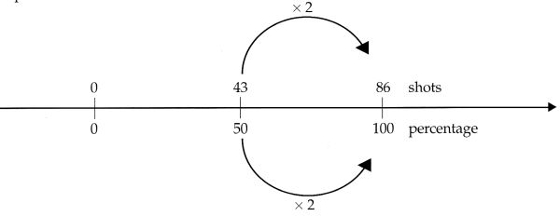
Calculate Sharelle’s shooting percentage and represent it on a double number line.

Exercise 1
Use the double number line to change the following fractions to percentages.
1) $\frac{1}{2}$ (2) $\frac{1}{4}$ (3) $\frac{3}{4}$ (4) $\frac{8}{\text{16}}$

5) $\frac{\text{10}}{\text{40}}$ (6) $\frac{\text{18}}{\text{24}}$ (7) $\frac{\text{35}}{\text{40}}$ (8) $\frac{\text{12}}{\text{20}}$

9) $\frac{8}{\text{24}}$ (10) $\frac{\text{18}}{\text{27}}$ (11) $\frac{\text{12}}{\text{36}}$ (12) $\frac{\text{15}}{\text{40}}$

Exercise 2: Word Problems
1) Tawera scored $\frac{\text{36}}{\text{45}}$ in his first science test and $\frac{\text{50}}{\text{60}}$ in his second science test. Change both test results to a percentage to find out which is the best one?

Independent Activity:
Use brochures from local retailers.
One shop has a “25% off” sale, another has a “one-third off” sale, and a third has a “40% off”
Sale. Give the students an arbitrary budget to spend at the three shops for them to decide which is the cheapest.
Hot Shots: Answers

Exercise 1
1) 50% (2) 25% (3) 75% (4) 50% (5) 25%
6) 75% (7) 87½% (8) 60% (9) 33$\frac{1}{3}$% (10) 66$\frac{2}{3}$%
11) 33$\frac{1}{3}$% (12) 37½%

Exercise 2
1) First test 80%, Second test 83$\frac{1}{3}$%

