Fraction Strategies
Hot Shots 1
Book 7 Pages 31-34
We are learning how to work out the percentages of amounts.
AC
EA
AP
AA
AM

Equipment: A set of percentage strips (Material Master 7-4), calculators, paper clips.

Note: The % sign comes from the “out of” symbol, /, and the two zeros from 100. It means “Out of 100”.
Percentages are used to compare fractions.

Problem: In an archery competition Tony scored a bullseye with 18 out of his 24 shots at the target. What percentage did he shoot?
Mapping 18 out of 24 on the number strips onto a base of 100 gives 75%.

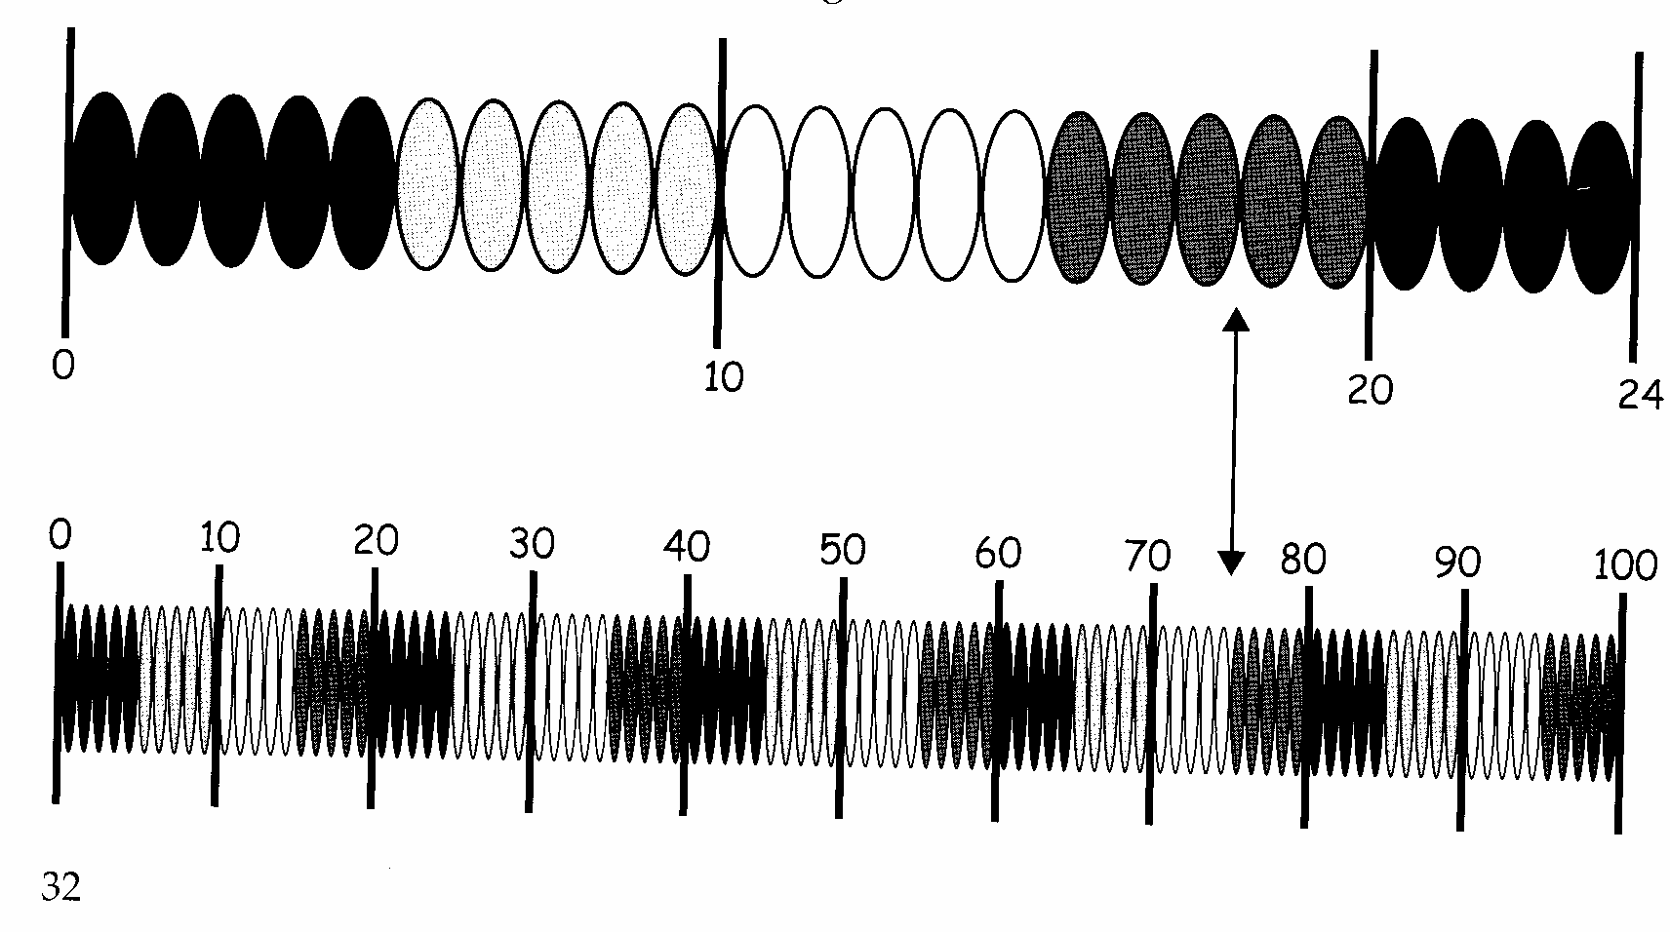

Exercise 1
Use the percentage strips to write the following as percentages
1) 9 out of 18 (2) 7 out of 28 (3) 12 out of 16

4) 6 out of 30 (5) 6 out of 15 (6) 16 out of 40

7) 20 out of 25 (8) 15 out of 20 (9) 24 out of 32

10) 25 out of 40

Exercise 2: Word Problems
1) In the last netball game Kyla got 15 out of her 20 shots at goal. What was her percentage success rate?

2) Daniel Carter kicked 9 out of 10 goals in the 2nd test against the British and Irish Lions in Wellington. What was his percentage success rate?

3) In 9C 9 out of the 20 students travel by bus to school each day whereas in 9E 11 out of the 25 students in the class travel by bus to school each day. Which class has the biggest percentage travelling by bus each day?
Hot Shots: Answers

Exercise 1
1) 50% (2) 25% (3) 75% (4) 20% (5) 40%
6) 40% (7) 80% (8) 75% (9) 75% (10) 62½%

Exercise 2
1) 75% (2) 90% (3) 9C 45% 9E 44% 9C has most by bus

